LESSON 4: SEMICONDUCTORS
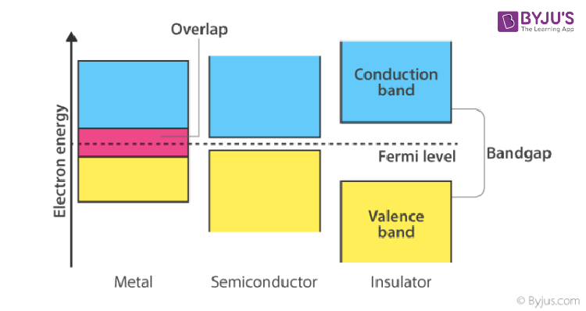

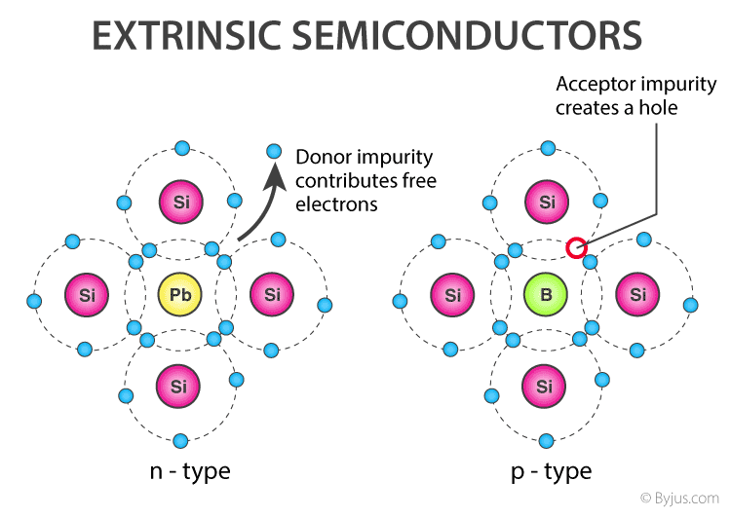

Property | Intrinsic Semiconductor | Extrinsic Semiconductor
Definition | Pure semiconductor material with no impurities. | Semiconductor material doped with impurities to enhance conductivity.
Examples | Pure silicon (Si), pure germanium (Ge). | Doped silicon or germanium (e.g., Si with phosphorus or boron).
Conductivity | Low, due to the limited number of charge carriers (electrons and holes). | Higher, due to the added charge carriers from doping.
Charge Carriers | Electrons and holes are equal in number. | Depends on the type of doping: electrons in n-type, holes in p-type.
Doping | No doping; pure material. | Doped with trivalent (p-type) or pentavalent (n-type) impurities.
Examples of Dopants | None (pure material). | - n-type: Phosphorus (P), Arsenic (As).  - p-type: Boron (B), Gallium (Ga).
Carrier Concentration | Determined by temperature and intrinsic properties of the material. | Determined by the concentration and type of dopants.

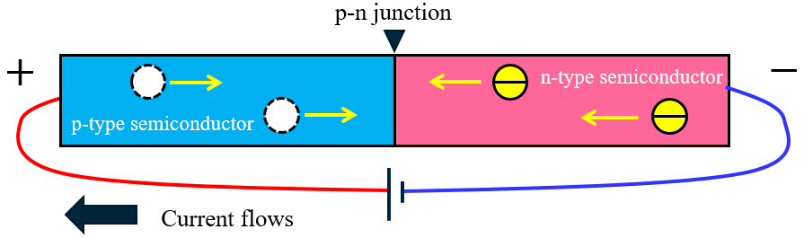

REVERSED BIASED
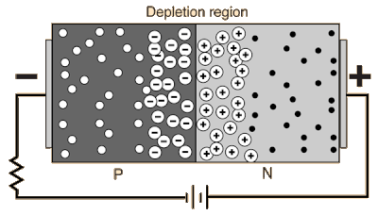

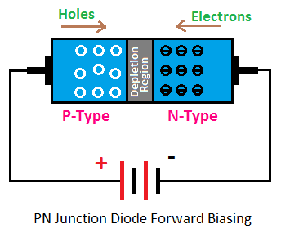
FORWARD BIASED

